**THIAGARAJARCOLLEGE OF ENGINEERING**

**(A Government Aided ISO 9001:2000 Certified Autonomous Institution Affiliated to Anna University)**

**Contact Address: C/o The Placement officer, Thiagarajar College of Engineering, Madurai – 625015**

**Telephone: +91+452+2482243 Email:** [**placement@tce.edu**](mailto:placement@tce.edu)

**Fax: +91+452+2483427 Website: www.tce.edu**

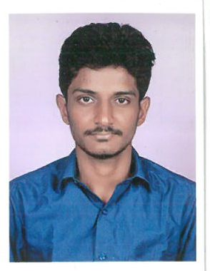

**RESUME**

NAME : M.R.KARTHIKEYAN

REG NO : **16Y026**

DEGREE : **MASTER OF COMPUTER APPLICATIONS**

**CAREER OBJECTIVE**

To become a software developer in a reputed organization to strive for the growth of the organization as well as my own personal growth.

**ACADEMIC RECORD**

|  |  |  |  |  |
| --- | --- | --- | --- | --- |
| **Course** | **Institution** | **Board /**  **University** | **Year of**  **Completion** | **Aggregate** |
| **MCA** | Thiagarajar College of Engineering, Madurai | Anna University, Chennai | 2019 | **7.40\*** |
| **BCA** | Thiagarajar College, Madurai. | Madurai Kamaraj University, Madurai | 2016 | **61.92** |
| **HSC** | St. Mary’s Higher secondary school, Madurai | State Board,  Tamil Nadu. | 2013 | **75** |
| **SSLC** | St. Mary’s Higher secondary school Madurai | State Board,  Tamil Nadu. | 2011 | **89** |

* CGPA (out of 10) upto 4rd semester

**COMPUTER PROFICIENCY**

* Language : Java , C++ , C
* Web Technologies: JavaScript, HTML.
* Database : Oracle10g.

**AREA OF INTEREST**

* Object Oriented Programming System(OOPS)

**CO- CURRICULAR ACTIVITIES**

* Participated as a Volunteer for ‘Quest 2017’, an Interschool Cultural Fest, organized by **Thiagarajar College Of Engineering** on 4th February 2017.
* To finish the dhakshan bharath hindi prachar sabha exams.
* To participated the spoken hindi exam passed the first class.
* Served as an NSS volunteer and participated in Social Services on various occasions.
* Acting as a Coordinator for Quiz in Techutsav-2k18 at Thiagarajar College of Engineering.

**PROJECTS**

* **CLOUD DATA PRODUCTION FOR THE MASSES**

Store large amount of data to clouds and access data using Secure key. Secure key provided admin after encrypting. And securely data to be Saved.

**TOOL USED: Front end: Java, Back end: My SQL**

**PERSONAL DETAILS**

**Name** : Karthikeyan M.R

**Father’s Name** : Mr.Rameshbabu M.K

**Gender** : Male

**Date of Birth** : 18-01-1996

**Marital Status** : Unmarried

**Nationality** : Indian

**Permanent Address** : 31A/85 Indira Nagar North Street

Kamarajapuram, Madurai-09.

**Contact number** : +91 7418837583

**E-mail ID** : karthi18011996@gmail.com

**Hobbies** : Listening to music, Playing Video Games

**DECLARATION**

I **Karthikeyan M.R, do**  here by declare that the above written particulars are true to the best of my knowledge and belief. I am also confident of my ability to work in a team.

Place: Madurai

Date : 06-09-2018

**(KARTHIKEYAN.M.R)**